CpE 272 Digital Logic Laboratory

Lab 1

Basic Logic Gates

Fall 2103

Prepared by: Olujide Jacobs

Prepared for: Matt Grubb

08/27/13

## Introduction

The purpose of this lab is to get students familiar with the functions and properties of basic logic gates, to provide students with some much needed experience with tools in the lab like the proto board and IC chips. The experiments in the lab were also designed to teach students how to connect circuits by merely looking at a circuit diagram, how to check if a logic gate is functioning as it should and how to determine the logic expression and truth table of a circuit.

## Experiments

In preparation for the 1st experiment, the team setup a proto board as instructed by the lab teaching assistant. This was accomplished by placing a 74LS08IC chip consisting of quad AND gates over the large gap in the middle of the proto board. The next step was to connect a wire from a +5v to a slot on the bus with a red line, and another one from a 0v (ground) to a slot on the bus with a blue line. The team then connected the Vcc pin on the 74LS08IC chip to five volts by connecting a wire from the 14th pin (Vcc pin) of the chip to a slot on the previously stated bus with a red line, and in a similar fashion connected the ground pin to ground by connecting a wire from the 7th pin of the chip to the previously stated bus with a blue line. This procedure was repeated throughout the lab, and the chip was changed depending on what part of the lab the team was working on.

Part I – AND gate:

Experiment 1:

The teams’ first task was to verify the AND operation by validating its truth table which is shown below



Methodology

The team laid the IC chip in place on the proto board before attempting to solve the problem. After doing that, the team used to wires to connect two pushbuttons to input 1 and 2 on the IC chip respectively and another wire to connect an LED to output 3.

Result

The LED light came on only when both inputs (pushbutton 1 & 2) were high, thus verifying that the above truth table.

Experiment 2:

Next, the team was asked to connect the circuit shown below and to use the results obtained to determine its logic expression and truth table using 3 pushbuttons and a LED.

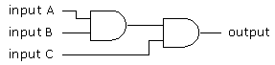

Methodology:

The team connected pushbuttons 1,2 & 3 to inputs 1,2 & 5 respectively and a LED to output 6 on the IC chip, while a wire was used to connect inputs 3 and 4 thus connect two AND gates.

Results:

The resulting circuit was a 3 input AND gate which had a high output whenever all its inputs were high, and a low output in any other circumstance. A high output in this case means that the LED lit up and a low output meaning vice-versa. Below is a representation of the team’s result in the form of a logic expression and a truth table.

Logic Expression:

Y=ABC



Low=0 and High=1

Part II – OR gate

Experiment 1:

In this experiment the team was asked to check if the provided OR gate was working by verifying its truth table which is shown below.



Methodology:

This difficulty was resolved by using a wire to connect two pushbuttons to input 1 & 2 respectively on the 74LS32 IC chip and an LED to output 3 on the chip.

Result

The LED light came on only when at least one input (pushbutton 1 & 2) or both were high, thus verifying that the OR gate was functioning properly.

Experiment 2: Once again the team was asked to connect a circuit (shown below) and to use the results obtained to determine its logic expression and truth table using 3 pushbuttons and a LED.

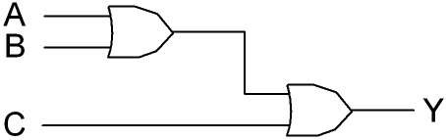

Methodology:

The team connected pushbuttons 1,2 & 3 to inputs 1,2 & 5 respectively and a LED to output 6 on the IC chip, while a wire was used to connect inputs 3 and 4 thus connect two OR gates.

Result

The resulting circuit was a 3 input OR gate which had a high output when at least one of its input was high, and a low output in any other circumstance. A high output in this case means that the LED lit up and a low output meaning vice-versa. Below is a representation of the teams’ result in the form of a logic expression and a truth table.

Logic Expression: Y=A+B+C



Low=0 and High=1

Part III – The NOT gate

Experiment 1:

The team was required to verify the truth table of the NOT gate shown below.



Methodology:

As always the first thing that was done was to lay the given IC chip in place on the proto board. The team then went about solving this by connecting a wire from a pushbutton to input 1 on the 74LS04 IC chip and an LED to output 2.

Result:

The LED lit up when the Input was low and went out when the input was high, thus verifying that it was functioning properly.

Experiment 2:

The next experiment was to connect the circuit shown below and to use the results obtained to determine its truth table using a switch and an LED.

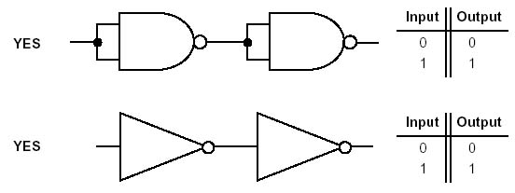

Methodology:

A wire was used to connect a switch to input 1 on the 74LS04 chip, and another wire was used to connect input 2 & 3 and lastly an LED was connected to output 4.

Result

The result was a circuit making use of two NOT gates where the LED lit up whenever the switch was on high, and dimmed down whenever the switch was on low. Below is a representation of the teams’ result in the form of a truth table



Part IV – The NAND gate

Experiment 1:

The problem faced here was to establish the condition of the NAND gate, in order to determine if it was functioning properly. The truth table for the NAND gate is shown below



Methodology:

The team laid the IC chip in place on the proto board then tackled the problem by connecting two pushbuttons to inputs 1 & 2 through the use of a wire, and an LED to output 3.

Result:

The LED lit up in all cases except in the case where both switches/pushbuttons were on high. Thus the NAND gate was confirmed to be functioning properly.

Experiment 2:

The team was then asked to connect both inputs of the NAND gates as shown in the figure below and apply one sign to them.

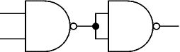

Methodology:

In order to connect both inputs of the NAND gate, a wire was connected to input 1 and another wire to input 2. The ends of both wires were connected to the same slot on the same column on the proto board, and another wire was connected from a pushbutton (switch) to the same slot as the other two wires. An LED was the connected to output 3 to serve as the signal.

Result:

The teams’ result showed that the NAND acted like a NOT gate. The LED lit up when the input was low and dimmed down when the input was high, exactly the same scenario when using a NOT gate. Below is a representation of the teams’ result in the form of a truth table



Experiment 3:

This experiment required the team to create an AND gate using only NAND gates.

Methodology:

This was achieved by using the first two pins of the 74SL00 chip as inputs for switches. A wire from output 3 was then used to join the input 4 & input 5 of the next NAND gate in the chip. Finally an LED was connected to output 6. This connection made is shown on the next page

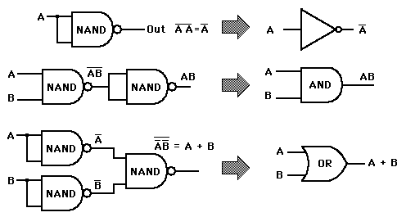

Result:

The team tested the circuit and used the result to form this truth table



The above truth table shows that the NAND gate (when connected as it is in the figure above) functions exactly like an AND gate.

Part V – The XOR gate

Experiment 1:

In this experiment the team was asked to check if the provided XOR gate was functioning the way it is supposed to by verifying its truth table (shown below).



Methodology:

In an attempt to verify the XOR gate, the team connected wires from two pushbuttons to inputs 1 & 2 respectively, and another wire from an LED to output 3.

Result:

The resulting truth table of the experiment is shown below



Part VI – Combinational Logic Networks

Experiment:

The task here was to design a circuit which signals when the numbers represented by some certain A,B & C lines are divisible by 3.

Methodology:

The team determined the following truth table for the circuit



Using the above truth table, the team designed the following equation by writing the Boolean equation from the truth table of the circuit.  


This was achieved by summing each of the minterms for which the output Y is true.

Using all this information, the team created a complex circuit which consisted of a series of NOT & AND gates, and a single or gate.

Result:

The resulting circuit was one that had a high output whenever the input represented a number divisible by 3, hence the circuit was a success.

### Conclusion

Before stepping into the lab I had minimal understanding of how logic gates worked. Now I have learned that the functions and properties of the basic gates – AND gate, OR gate, XOR gate and NOT gate. I have also learned the functions and properties of the NAND gate, NOR gate and XNOR gate. Evidence of this is seen in my ability to determine the truth table for the different circuits that were built during this lab. I also learned how to properly prepare a prototype board for experiments. Overall my learning in this lab has been excellent, I did have to put in some extra hours even after the lab to fully understand it, but it was worth it.Post Lab Questions for Lab 1

Q 1

|  |  |  |  |
| --- | --- | --- | --- |
| Input A | Input B | Input C | Output Y |
| 0 | 0 | 0 | 0 |
| 0 | 0 | 1 | 0 |
| 0 | 1 | 0 | 1 |
| 0 | 1 | 1 | 0 |
| 1 | 0 | 0 | 1 |
| 1 | 0 | 1 | 0 |
| 1 | 1 | 0 | 1 |
| 1 | 1 | 1 | 0 |

Q 2

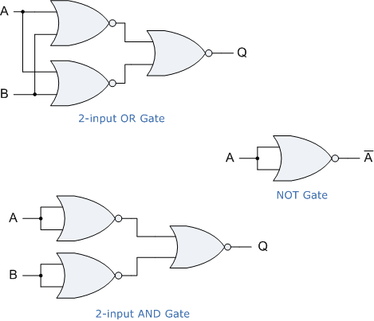

Pre Lab Questions for Lab 1

AND - &

OR - #

NOT - !